Loyalsock Trail T-Shirts

Orders and payment due in office by 11/22/2017
Due to interest and Christmas on its way we are offering another
SPECIAL ORDER for SHIRTS


Long Sleeve T-shirts. Military Green. LT Blaze on left chest.
Trail map on back with key points of interest.

Cost per Shirt: $20.00. (Local to Williamsport, meet up for no delivery fee.)

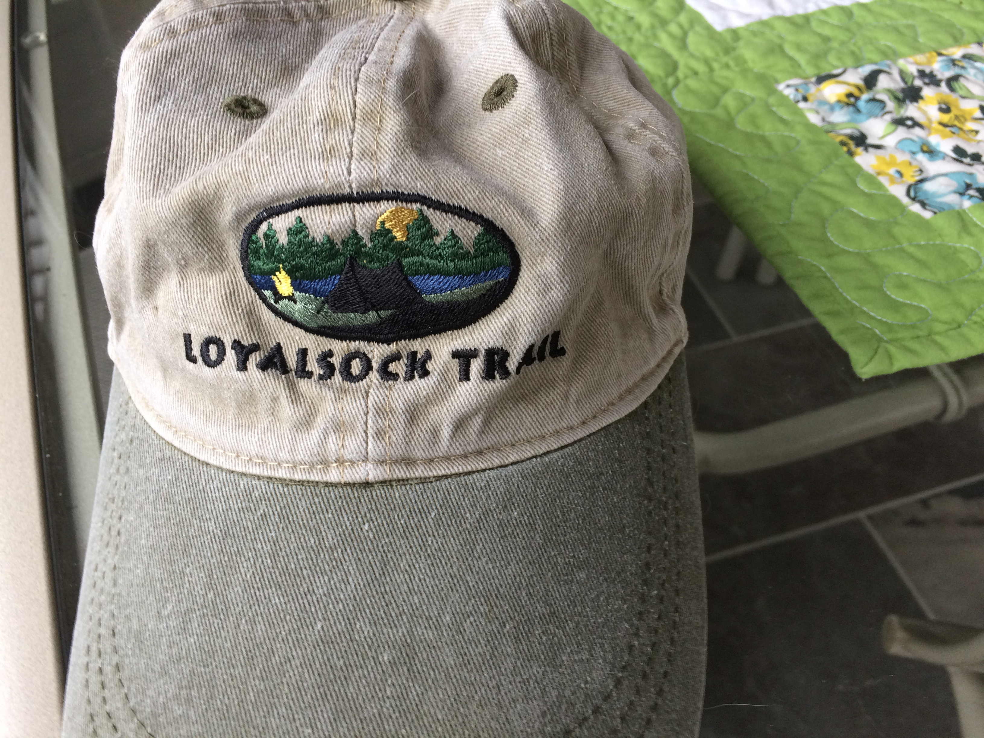
Size and how many:

____S ____M ____L ____XL ____XXL

Embroidered Cap:

_____One size $15.00

Additional cost for shipping: 1-2 items $6.00 3-4 items $14.00 5-6 items $20.00
(Local to Williamsport, meet up for no delivery fee.)
Your Name______________________________________________________________

Shipping Address_________________________________________________________

Phone number or email for contact information__________________________________

Check payable to: Alpine Club of Williamsport

Mail completed Order form and check: (Receipt of order and check will be confirmed if you provide your contact information.)

Sue Stackhouse
274 Henry Drive
Montoursville PA 17754

Please note: Information on purchasing Loyalsock Trail Embroidered Patchs and Trail Guides can be found on our website.

